Assignment 26.3

Use real_estate to solve queries. Link: Real_Estate.csv

● Create table RealEstate in Hive database, with all the columns present in dataset.

● Load dataset into table realEstate.

● Using Dynamic partition get separate lists of residential apartments with more than 2 beds and include columns in following order City,Baths,Sq_feet,Price,flat_type,Beds respectively.

First, creating the table as real_state1 and then loading the given dataset into the table.

Then, creating another table which is partitioned by beds.

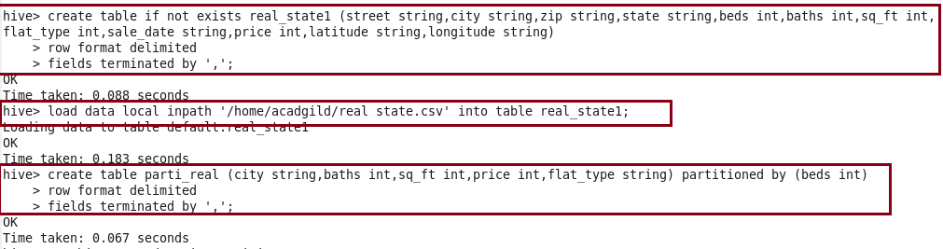

To use the dynamic partitioning in hive we need to set the below parameters in hive shell.

Inserting the data into the partitioned table from the created table real_state1

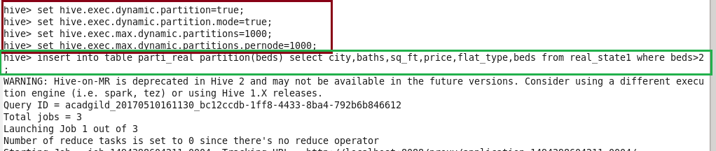

Now, listing the contents created in the table ‘parti_real’ and then displaying the data for the bed count whatever we want. I am displaying for beds=3.

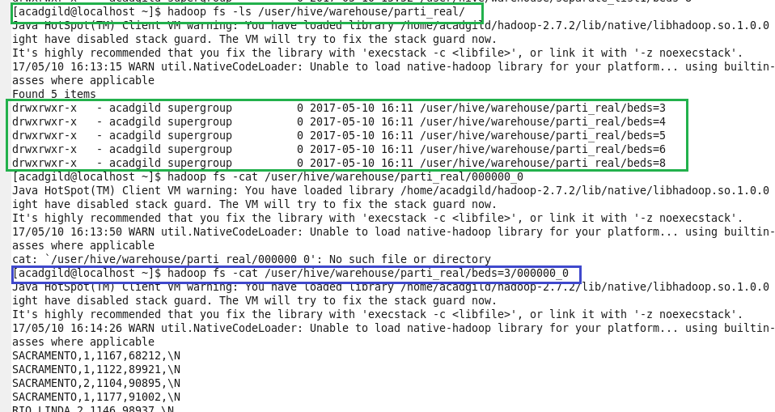

Output :

